Week-14-Structures and Unions

Reg no : 241801304

Name : Ukirtha S

Q1)

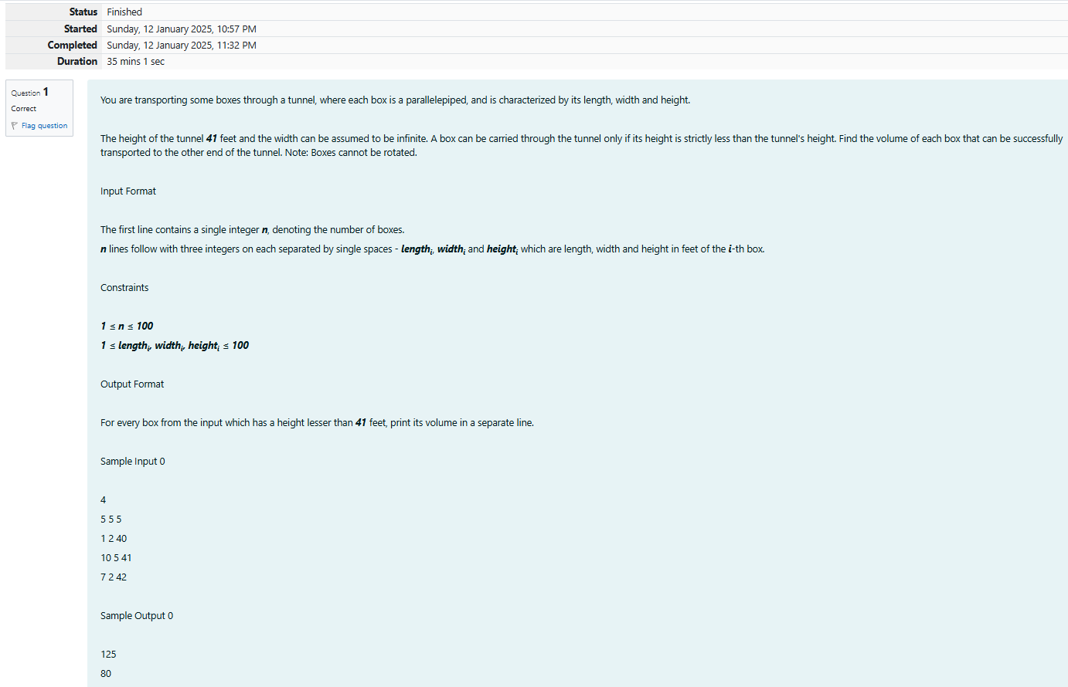

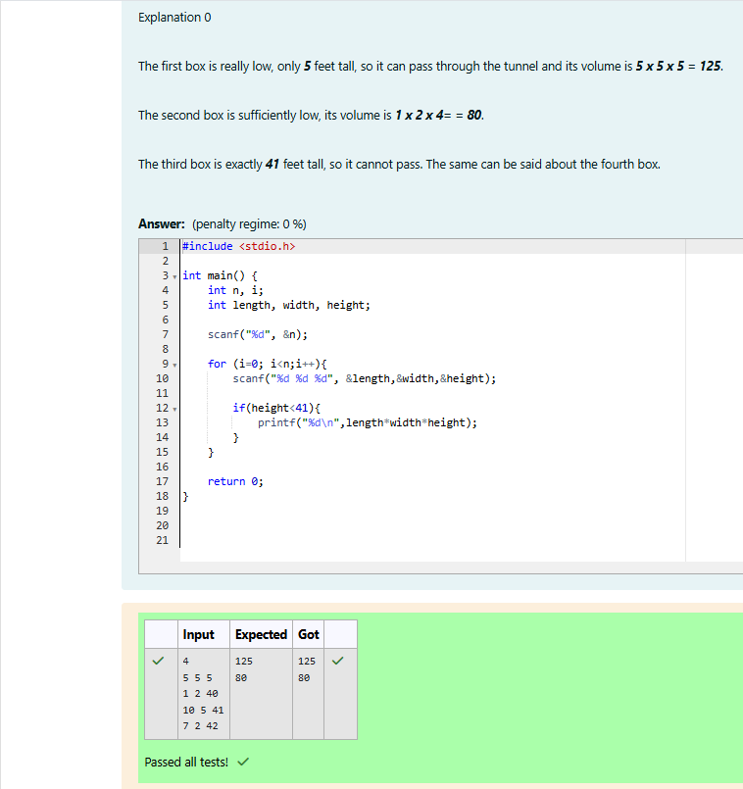

Reg no : 241801304

Name : Ukirtha S

Q2)

